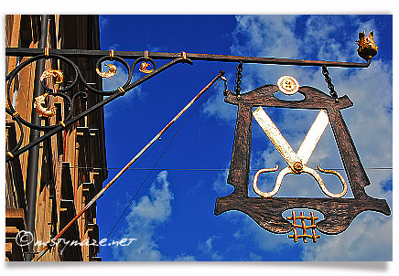

http://mistymaze.net/wordpress/wp-content/uploads/2009/06/os6.jpg

